**Pie Bakery Analysis**

I have taken a data of pie bakery from year 2019 to 2022 to perform some analysis and find the answer for the following questions:

* How many items are sold per Year, Quarter and months?
* Give a weekdays comparison of total orders.
* Calculate the total revenue by Quarters.
* Calculate number of orders by gender.

Steps:

* Gather all the data and clean it as per your requirements.
* After your data is cleaned convert the data to pivot table and make pivot table and charts as per your requirements.
* Create an interactive dashboard using charts and slicer.

Data used for my project:

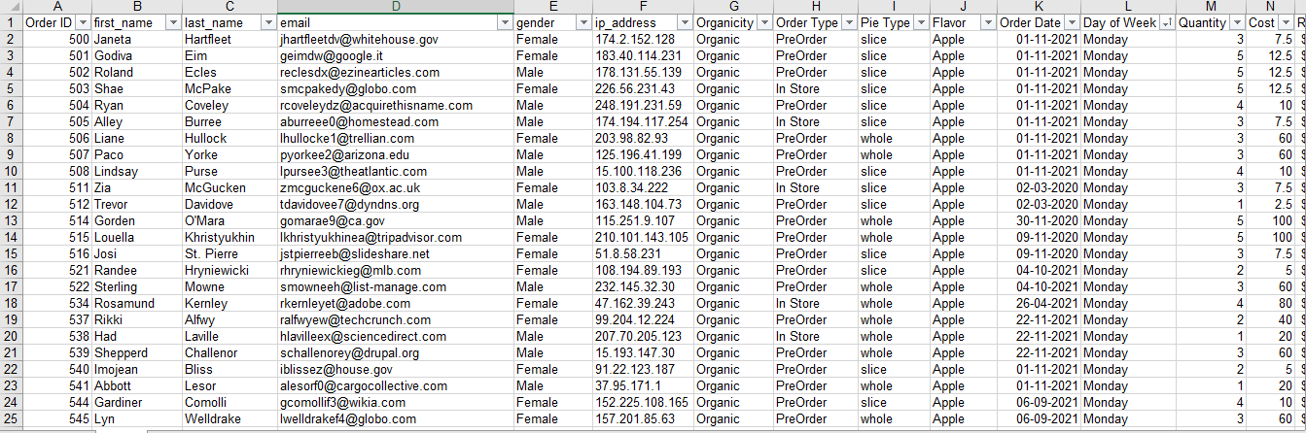

Pivot tables:

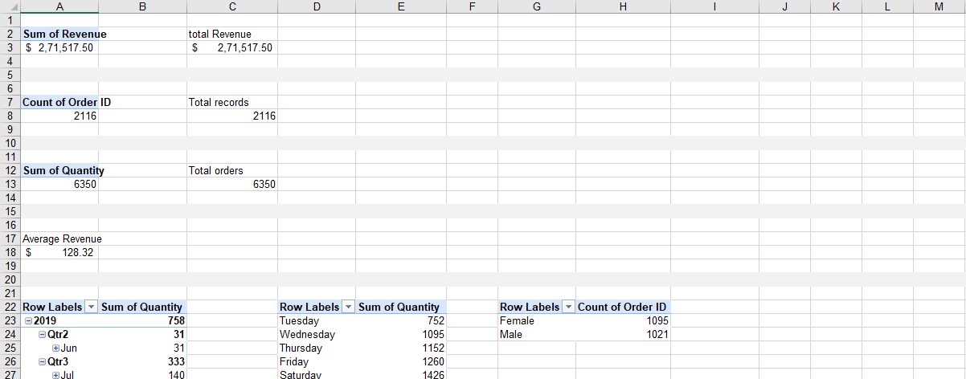

Dashboard:

